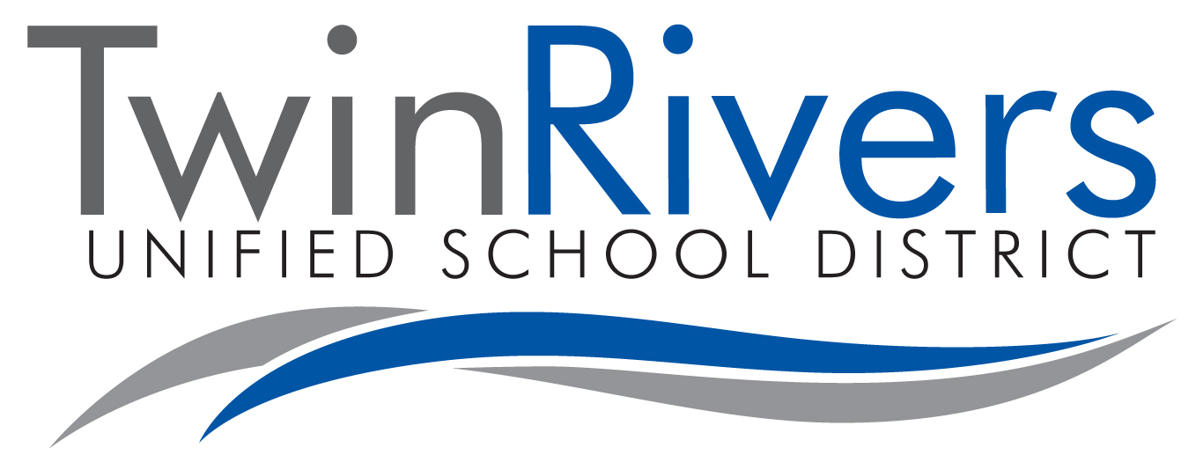

INFORMAL HOME LANGUAGE SURVEY

Child’s Name: ___________________________________ Date of Birth: __________

SITE: ◻ Morey ◻ Oakdale ◻ Rio Linda ◻ Village

What language does your child speak at home? _________________________

Speaking and Understanding in English

Is your child able to speak English? ◻ Yes ◻ No

Is your child able to understand English? ◻ Yes ◻ No

What percentage of time does your child understand English?

◻ 0% ◻ 25% ◻ 50% ◻ 75% ◻ 100%

